**vi editor:**



**Modes of vi editor:**

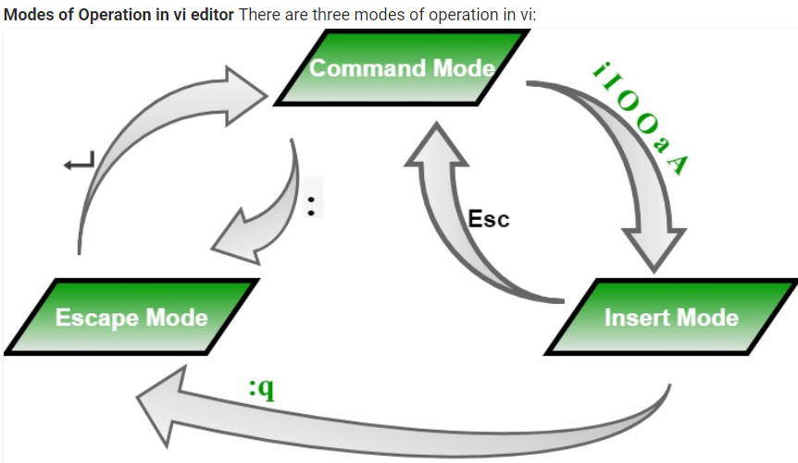

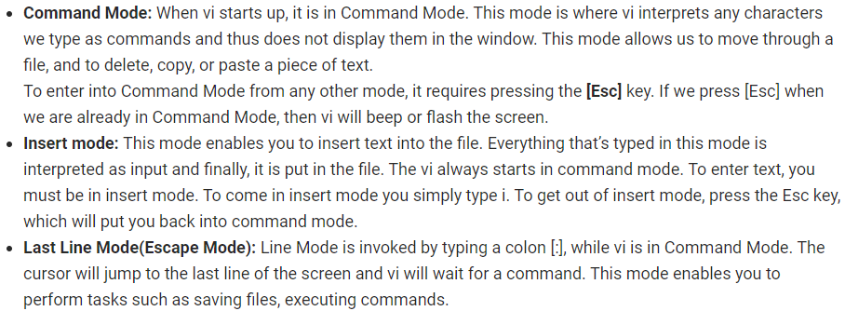

**Starting the vi editor:**

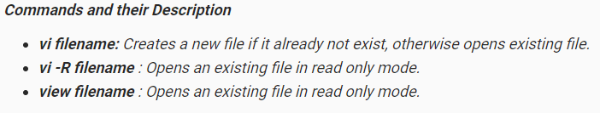

**Moving within a File(Navigation):**

* To move around within a file without affecting text must be in command mode (press Esc twice). Here are some of the commands can be used to move around one character at a time.

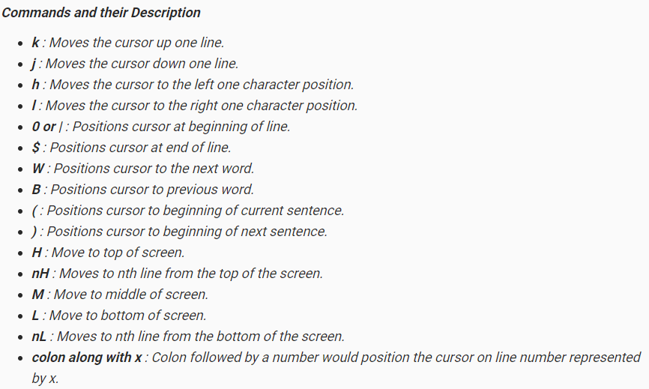

**Control Commands (Scrolling):**

* There are following useful commands which can used along with Control Key

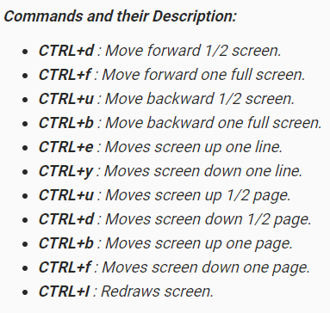

**Editing and inserting in Files(Entering and Replacing Text):**

* To edit the file, we need to be in the insert mode. There are many ways to enter insert mode from the command mode.

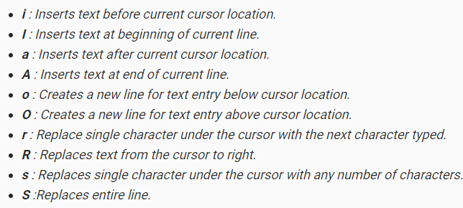

**Deleting Characters:**

* Here is the list of important commands which can be used to delete characters and lines in an opened file.

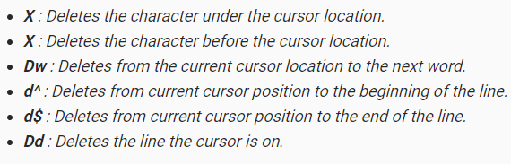

**Copy and Paste Commands:**

* Copy lines or words from one place and paste them on another place by using the following commands.

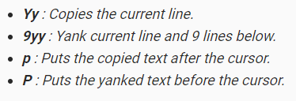

**Save and Exit Commands of the ex Mode :**

* Need to press [Esc] key followed by the colon (:) before typing the following commands:

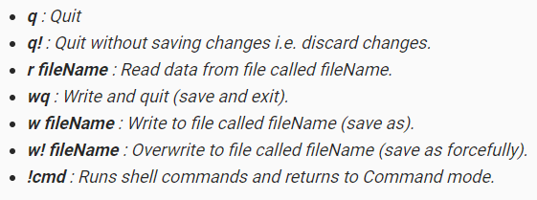

**Searching and Replacing in (ex Mode):**

* vi also has powerful search and replace capabilities. The formal syntax for searching is:

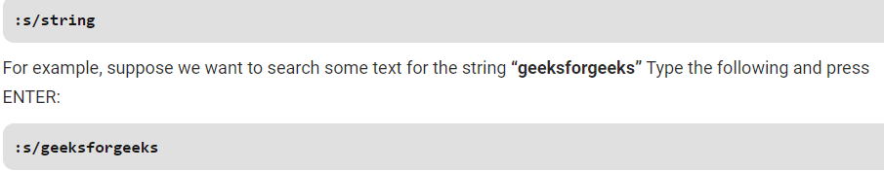

* The syntax for replacing one string with another string in the current line is

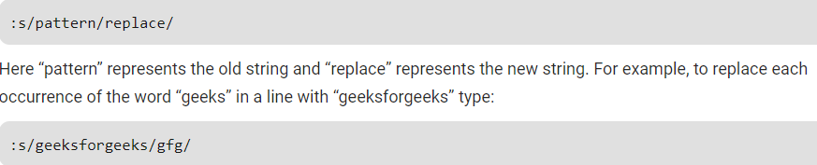

* The syntax for replacing every occurrence of a string in the entire text is similar. The only difference is the addition of a “%” in front of the “s”

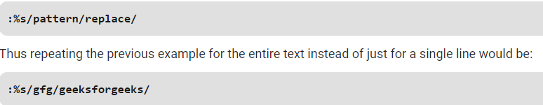

* This also works if we want to delete some key word or a line of text as below.

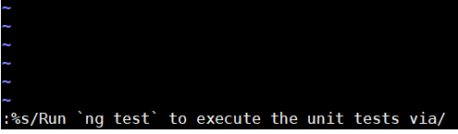

**To search for any keyword case insensitive in vi editior:**

